**PIZZA SALES SQL QUERIES**

**A. KPI’s**

**1. Total Revenue:**

select sum(total_price) as total_revenue from pizza_sales;

**2. Average Order Value**

select sum(total_price)/count(distinct order_id) as avg_order_value from pizza_sales;

**3. Total Pizzas Sold**

select sum(quantity) as total_pizza_sold from pizza_sales;

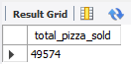

**4. Total Orders**

select count(distinct order_id) as total_order from pizza_sales;

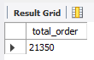

**5. Average Pizzas Per Order**

SELECT CAST(CAST(SUM(quantity) AS DECIMAL(10,2)) /

CAST(COUNT(DISTINCT order_id) AS DECIMAL(10,2)) AS DECIMAL(10,2))

AS Avg_Pizzas_per_order

FROM pizza_sales;

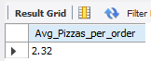

**B. Hourly Trend for Total Pizzas Sold**

SELECT HOUR(order_time) as order_hours, SUM(quantity) as total_pizzas_sold

FROM pizza_sales

GROUP BY HOUR(order_time)

ORDER BY HOUR(order_time);

***Output***

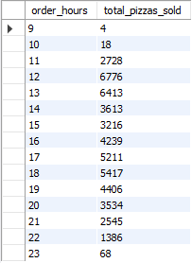

**C. Weekly Trend for Orders**

SELECT WEEK(STR_TO_DATE(order_date, '%m-%d-%y'), 3) AS WeekNumber,YEAR(STR_TO_DATE(order_date, '%m-%d-%y')) AS Year,

COUNT(DISTINCT order_id) AS Total_orders

FROM pizza_sales WHERE order_date IS NOT NULL AND STR_TO_DATE(order_date, '%m-%d-%y') IS NOT NULL

GROUP BY WeekNumber,Year

ORDER BY Year, WeekNumber;

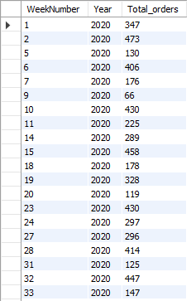

**D. % of Sales by Pizza Category**

SELECT pizza_category, CAST(SUM(total_price) AS DECIMAL(10,2)) as total_revenue,

CAST(SUM(total_price) * 100 / (SELECT SUM(total_price) from pizza_sales) AS DECIMAL(10,2)) AS PCT

FROM pizza_sales

GROUP BY pizza_category;

***Output***

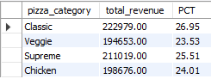

**E. % of Sales by Pizza Size**

SELECT pizza_size, CAST(SUM(total_price) AS DECIMAL(10,2)) as total_revenue,

CAST(SUM(total_price) * 100 / (SELECT SUM(total_price) from pizza_sales) AS DECIMAL(10,2)) AS PCT

FROM pizza_sales

GROUP BY pizza_size;

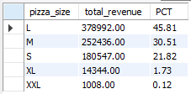

**F. Top 5 Pizzas by Revenue**

select pizza_name,sum(total_price) as total_revenue from pizza_sales

group by pizza_name

order by total_revenue desc

limit 5 ;

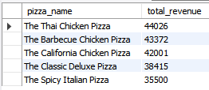

**G. Bottom 5 Pizzas by Revenue**

select pizza_name,sum(quantity) as total_quantity from pizza_sales

group by pizza_name

order by total_quantity asc

limit 5 ;

